1. **Install the following Linux distribution and release on your own computer: Ubuntu Desktop 64-bit 18.04 LTS. It is essential that you install this distribution and release so that you will not have problems like “was working on my machine”. You can install Linux on bare hardware, i.e., on a partition of your hard-disk. In this case, make sure you first backup all your important data so that you will not lose your data in case your computer does not boot up after installation.**

**You can also install Linux in a virtual machine created in your computer. For this, you first need to install a virtualization software, VMware or VirtualBox (or some other virtualization software), on your computer. VirtualBox is free to use. VMware Player is also free to use. If you have, you can also use VMware Fusion (for OS X) or VMwareWorkstation.**

* Download the VMWare VirtualBox for the safe installation of Linux on that virtual machine.

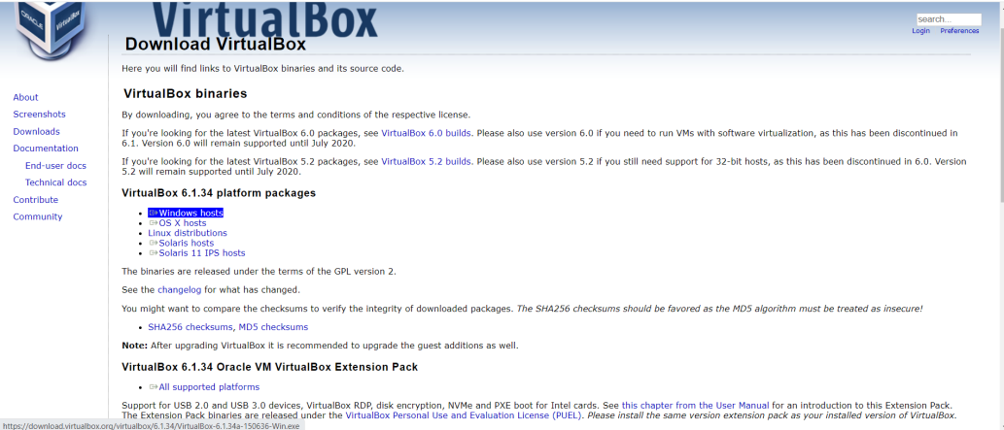

* After the download the following set up are done:

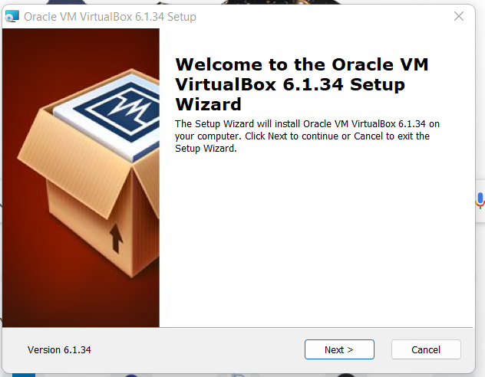

* Click Next.

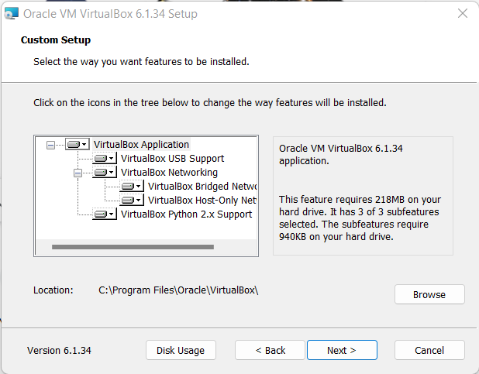

* Click Next

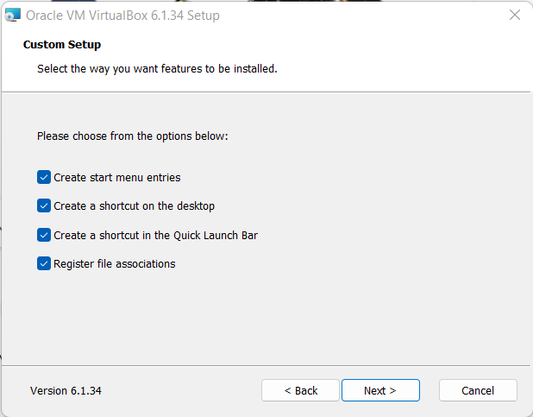

* Click Next.

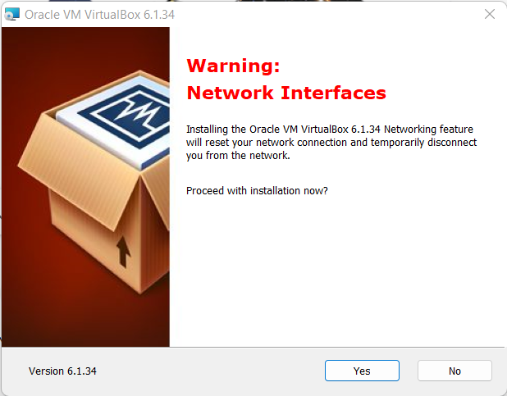

* Click Next

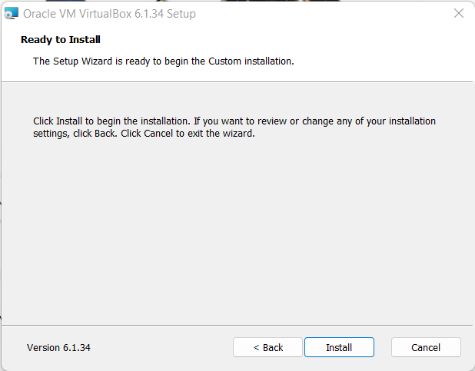

* Click Install

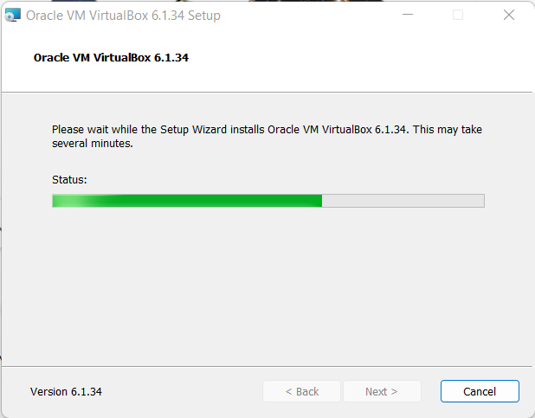

* Click on new and set the path

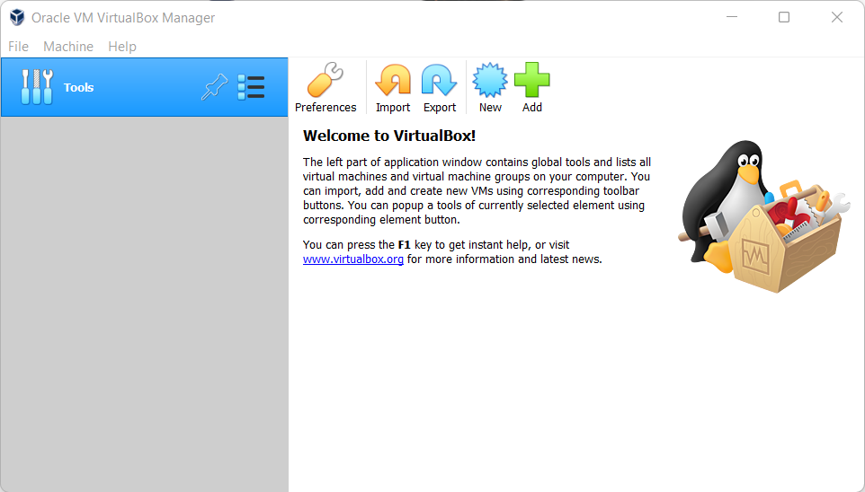

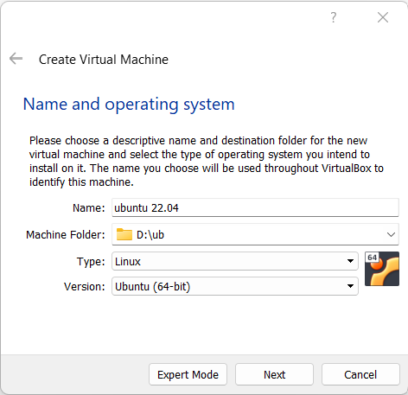

* Click Next

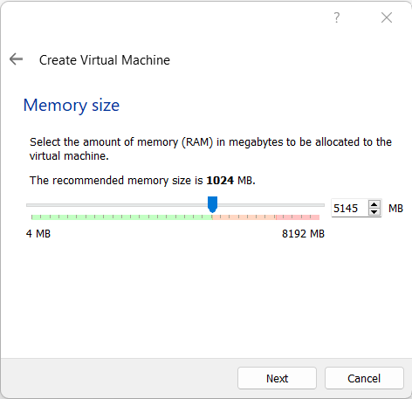

* Set memory size till green color in bar ends and click Next.

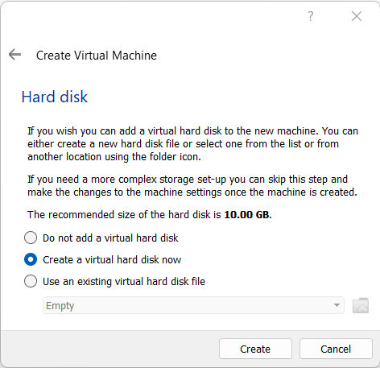

* Click Create

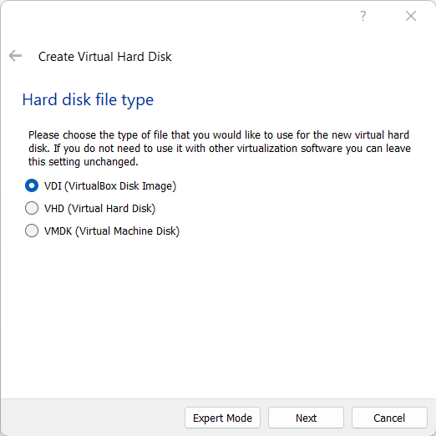

* Click Next.

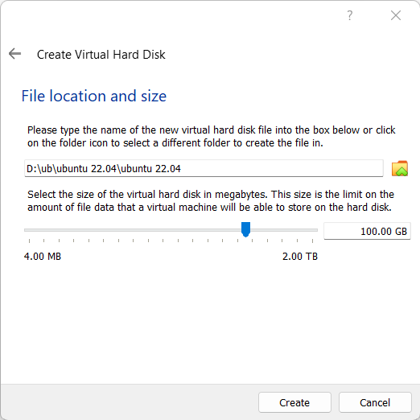

* Make virtual hard disk size 100GB and click Next.

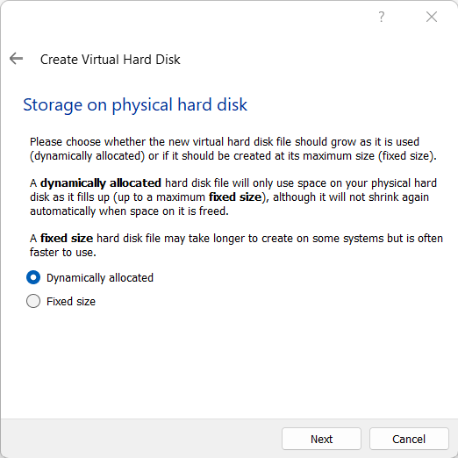

* Click Next.

Now the installation will begin.

* Now download Latest version of Ubuntu and after its generated you can add the instance or generate the file to run Ubuntu in this Virtual machine. Add the downloaded file to the iso file for that generated instance in the virtual machine.
* Then the system will start working and you can run all the Linux commands here…

1. **Write briefly about your installation choices and experiences in your report. After installing Linux, start Linux and learn basic Linux usage. There are lots of guides and tutorials in Internet teaching basic Linux usage. You can benefit from them. In your report, write down the names of 10 Linux commands that you learned.**

**ls**

The ls command is used to list files or directories in Linux and other Unix-based operating systems

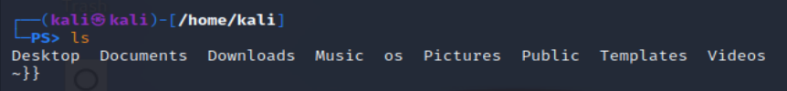

**mkdir**

The ls command is allows users to create or make new directories.

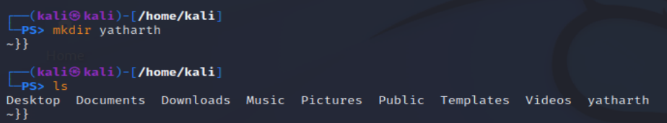

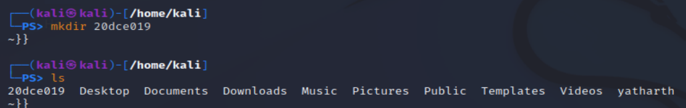

**mv**The ls command is used to moves files and directories from one directory to another, or renames a file or directory.

**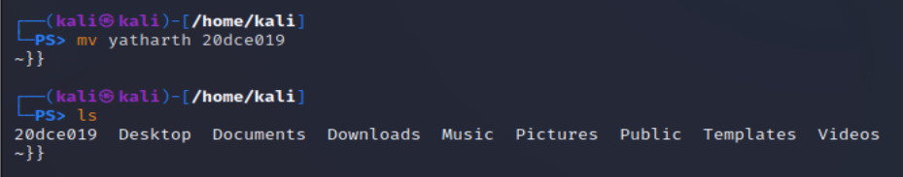  
cd**Change current working directory.

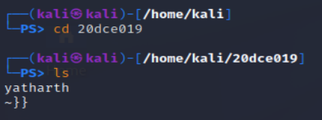

**rmdir**

The ls command is used to removes empty directories specified on the command line.

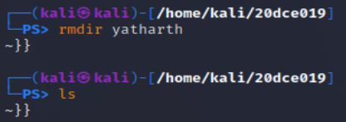

**pwd**The ls command is used to writes to standard output the full path name of your current directory (from the root directory).

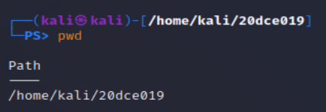

**touch**The ls command is used to primary function is to modify a timestamp.

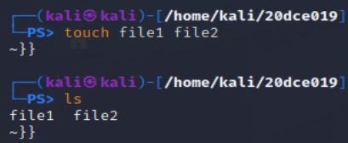

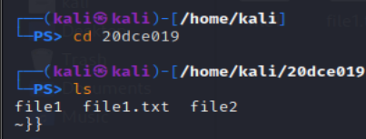

**rm**The ls command is used to delete files.

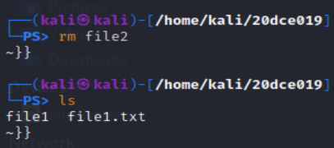

**man**display the user manual of any command that we can run on the terminal.

**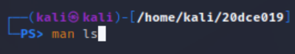  
  
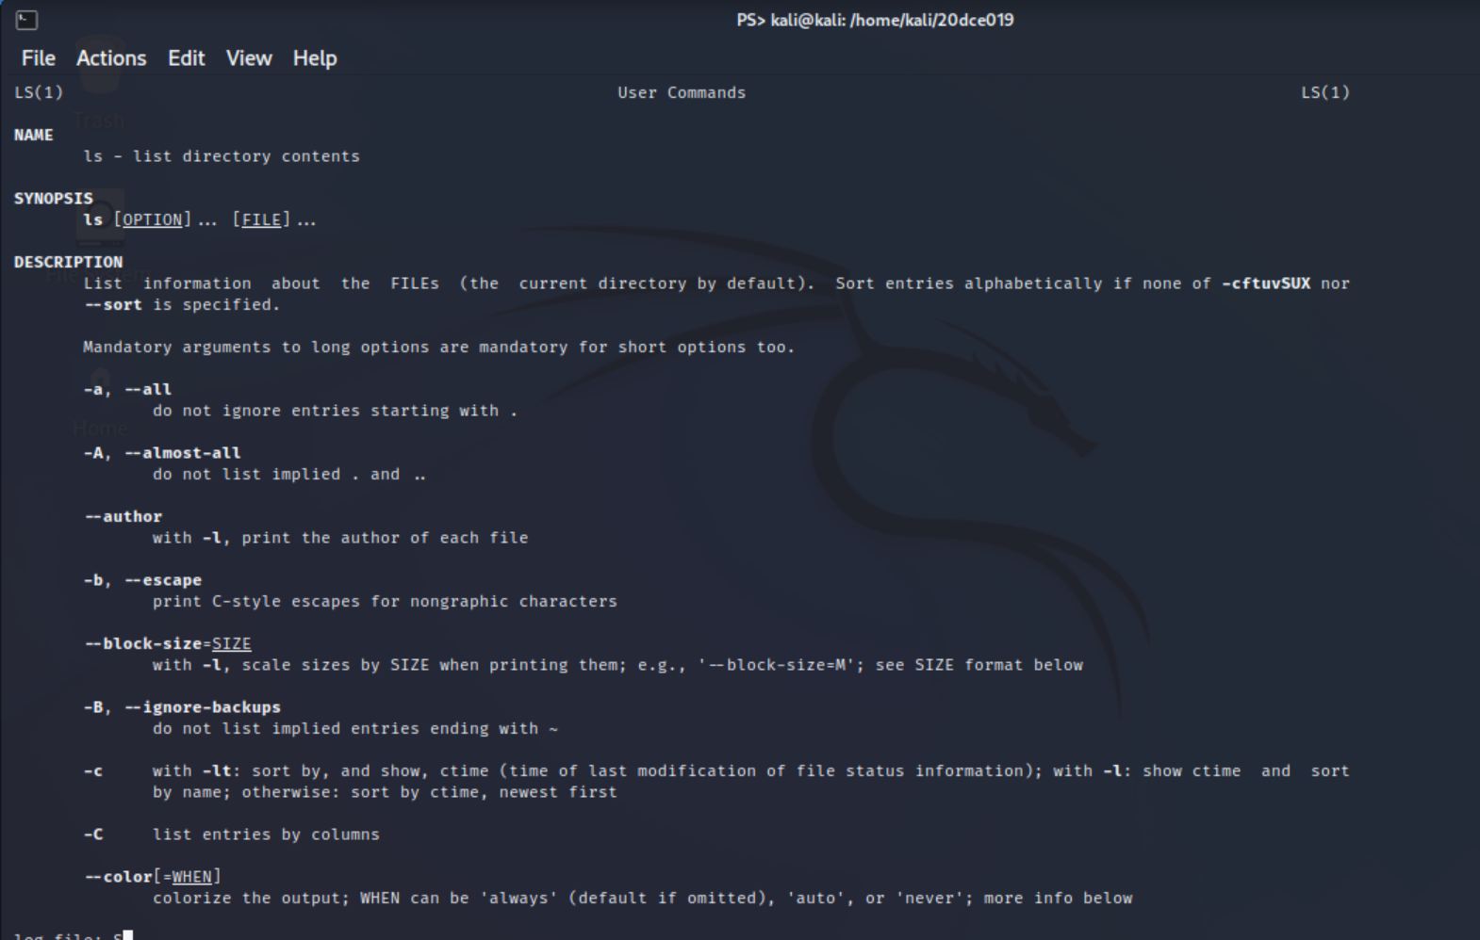**

1. **Find out and write down the location (pathname) where the kernel executable resides in the default directory tree (starting with “/ “) of your Linux installation. Find out the version of your running kernel by using the “uname –r” command. Write the version number in your report.**

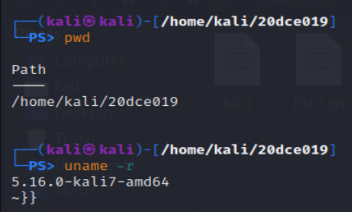

1. **Download the source code of the Linux kernel (from kernel.org, for example). Download the version that is close to the version of your running kernel. After opening the tar package, change into the root directory of the downloaded kernel source code (it is in the directory where you downloaded the tar package), and in your report write the names of the subdirectories you see there.**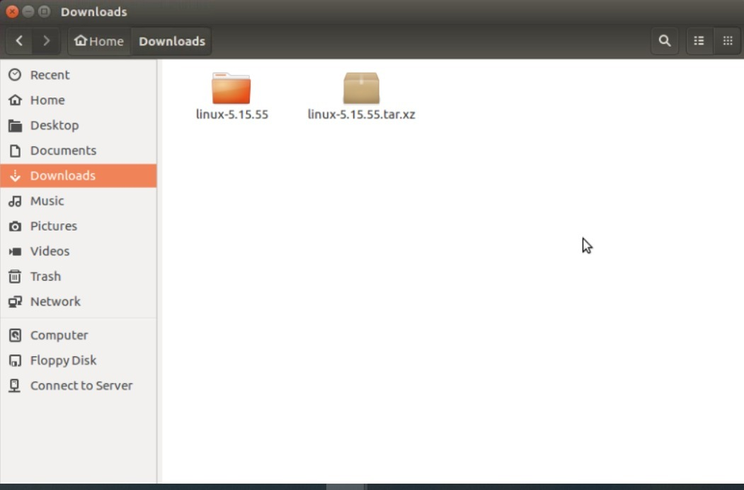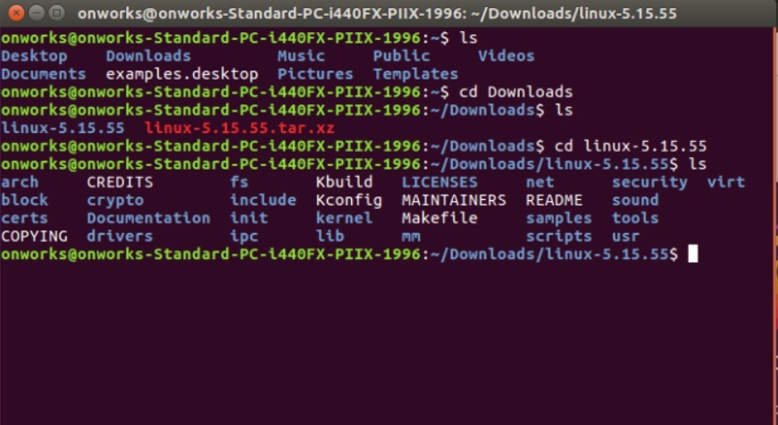
2. **In the source code of the kernel, find out the definition of the system call table. Write the pathname where you found it. Then, examine the table. Find out the system call names corresponding to system call numbers 5, 43, 123, and 220.**

* **Not to be done yet.**

1. **Use the strace command of Linux to trace the systems calls made by some simple programs like cp, ls, etc. Use the manual page of strace to learn more about it (type man strace). Include sample output in your report. The “man” command provides help pages about Linux commands, system calls, and C library functions.**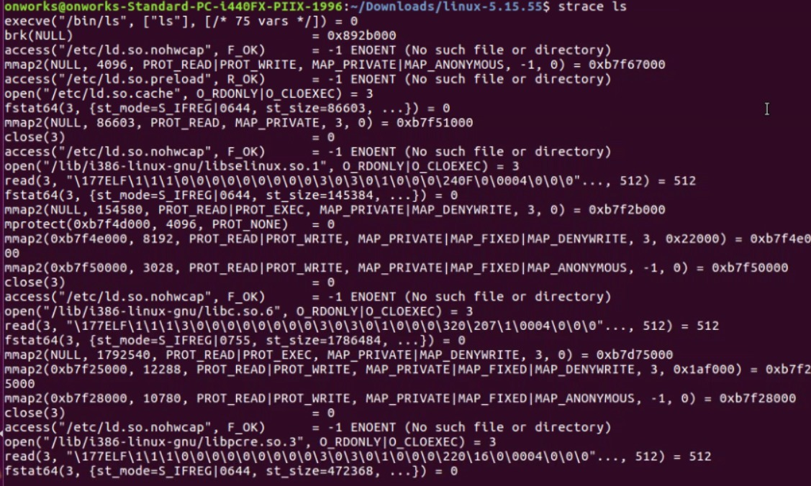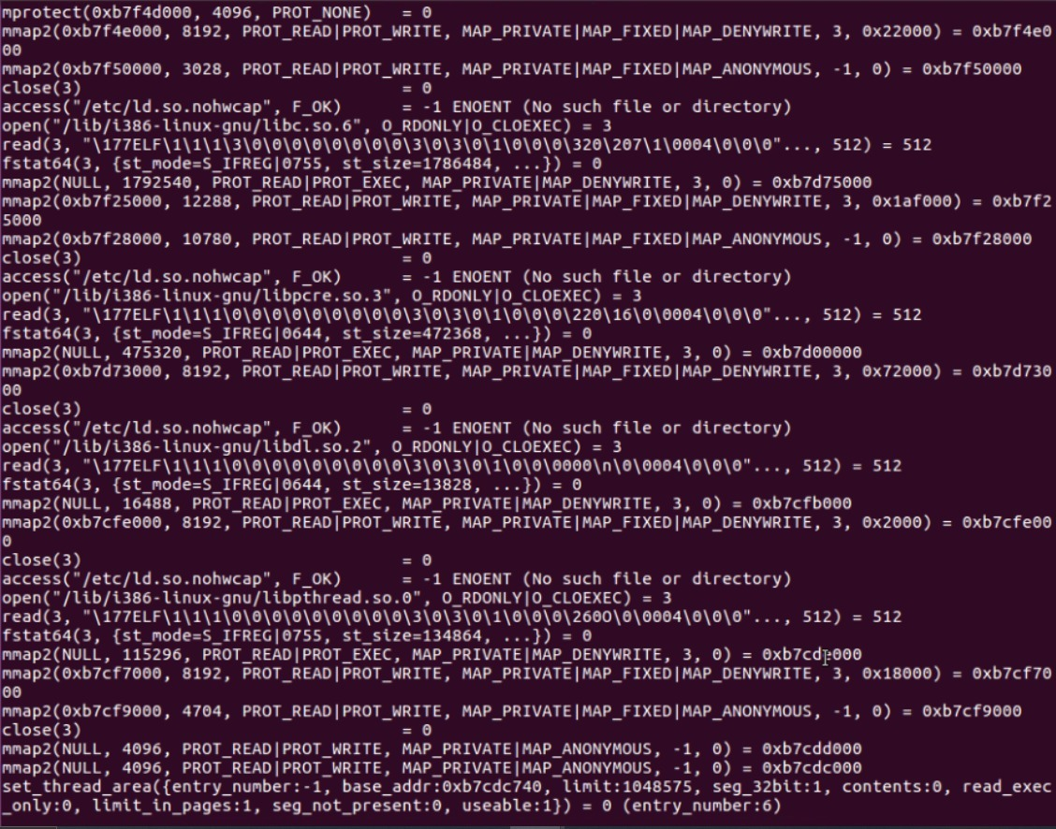

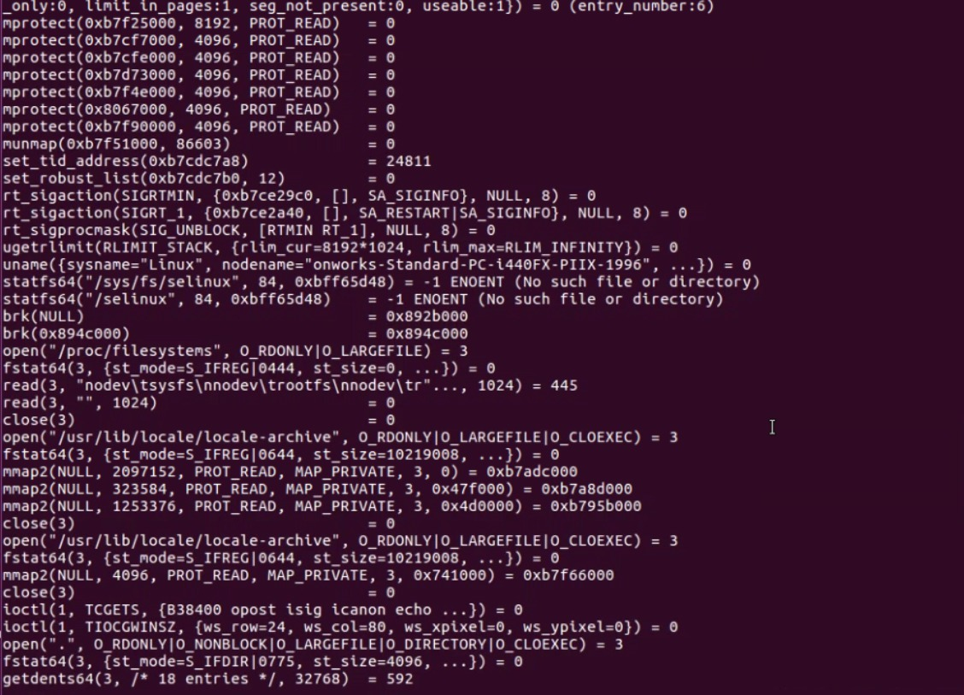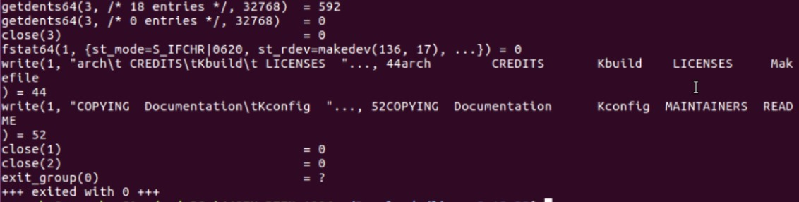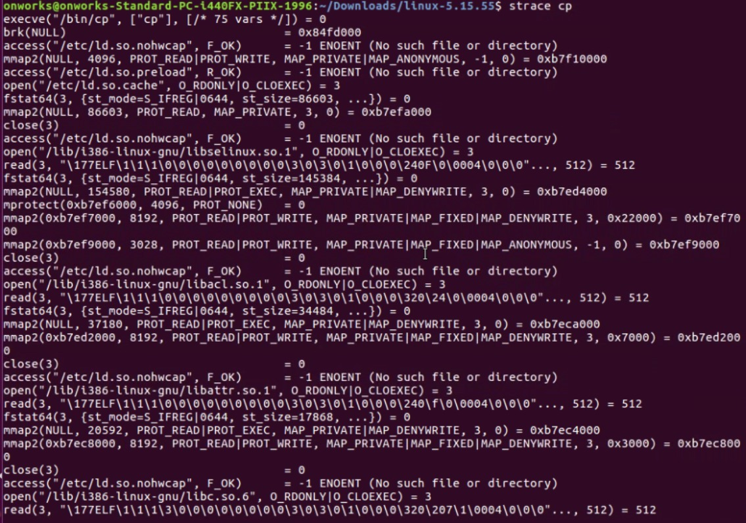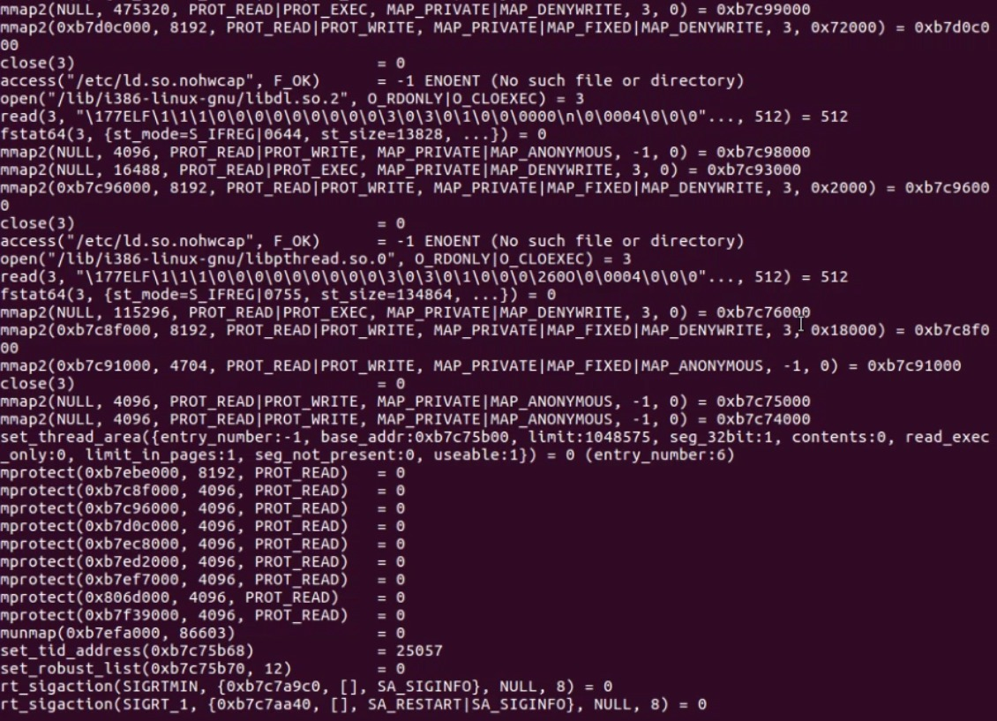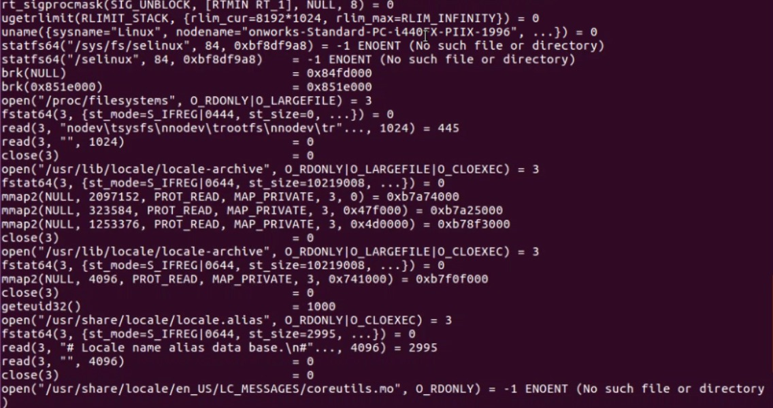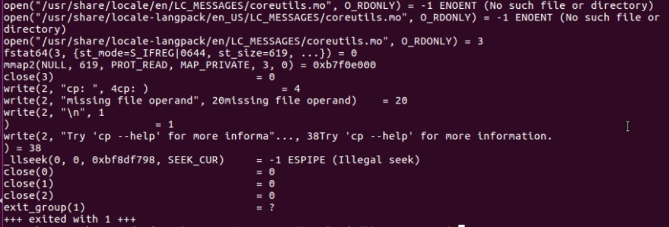

1. **Use the time command to measure the time required to execute some programs like cp, etc. It reports different times: real, user and sys. What are they? Write those values for different program executions.**

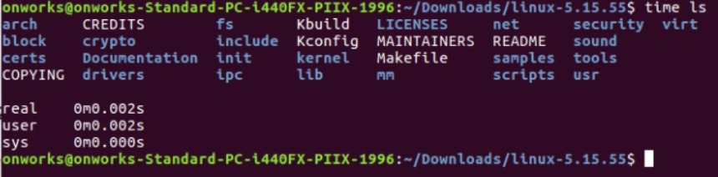

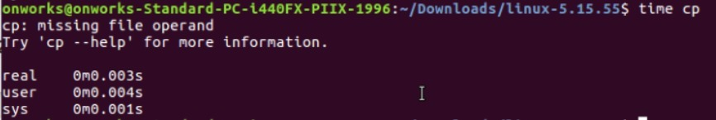

**Write a simple C program to compare the cost (in terms of elapsed time) of different system calls with different parameter values. Different system calls can be: getpid(), read(), write(), open(), mkdir(), etc. Different parameter values, for example for the read() system call, can be: read 100 bytes, 1000 bytes, 10000 bytes, or 100000 bytes into a buffer of enough size. You can call the program as cost.c. To get the current time in the program you can use the gettimeofday() system call. It gives the current time in microseconds granularity. You can call this before and after a system call is made to measure the elapsed time.  
  
Write a simple Makefile to compile your program. A Makefile is a set of directives and commands specified in a file to compile a project. The following can be a starting point for your Makefile content. Be careful about TAB characters.**

**all: cost**

**cost:Not cost.c**

**gcc –Wall –g -o cost cost.c**

**clean:**

**rm -fr cost cost.o *~**

* **Not to be done yet.**